1. General Technical Specification of the Numbering boxes for sequential numbering of banknotes

Required technical parameters

|  |  |  |  |
| --- | --- | --- | --- |
| **Nr.** | **Request of Contracting Authority:** | **Required amount (pcs)** | **The declaration of supplier that it meets all the requirements of the Contracting Authority:** |
| 1 | Numbering boxes with typical print: **000AB111111** (horizontal + vertical)  A = Letter wheel 11 division  B = Letter wheel 11 division  0 = Figure wheel 11 division, engraved 0-9 and low blank  1 = Figure wheel automatic counting  re: orientation of vertical print see enclosed Picture 1 | 120 | [YES / NO] |
| 2 | 11 digits, forward counting, Pre-Inking device for the automatic figure  wheels; Designed for printing speed minimal 10.000 sheet per hours | - | [YES / NO] |
| 3 | Engraving: OCR-B no. 302 for figures and OCR-B no. 304 for letters with increased figure height 3,3 mm, center distance 3,32 mm | - | [YES / NO] |
| 4 | Letter wheels, horizontal - engraved: ABCDEFGHIJ and low blank | 120 | [YES / NO] |
| 5 | Additional letter wheels, horizontal - engraved: KLMNOPQRST and low blank | 120 | [YES / NO] |
| 6 | Additional letter wheels horizontal - engraved: UVWXYZZZZZ and low blank | 120 | [YES / NO] |
| 7 | Letter wheels, vertical - engraved: ABCDEFGHIJ and low blank | 120 | [YES / NO] |
| 8 | Additional letter wheels, vertical, Position 7 - engraved: KLMNOPQRST and low blank | 60 | [YES / NO] |
| 9 | Additional letter wheels, vertical, Position 8 - engraved: KLMNOPQRST and low blank | 60 | [YES / NO] |
| 10 | Additional letter wheels, vertical, Position 7 - engraved: UVWXYZZZZZ and low blank | 60 | [YES / NO] |
| 11 | Additional letter wheels, vertical, Position 8 - engraved: UVWXYZZZZZ and low blank | 60 | [YES / NO] |
| 12 | Split design (base + numbering wheels assembly) to maintain adjusted position of a print | - | [YES / NO] |
| 13 | Tool less daily use (“click-in” design) | - | [YES / NO] |
| 14 | Same base for horizontal and vertical numbering | 120 | [YES / NO] |
| 15 | Common spare parts for horizontal and vertical numbering boxes | - | [YES / NO] |
| 16 | Use of different fonts / pitches in one common wheels assembly | - | [YES / NO] |
| 17 | Modification of existing numbering machine Koenig & Bauer AG Numerota II (S/N 64700903) | | |
| 18 | Cams with single sided cam track, for horizontal print | 5 | [YES / NO] |
| 19 | Cams with single sided cam track, for vertical print | 5 | [YES / NO] |
| 20 | Holding rings | 10 | [YES / NO] |
| 21 | Counterweights | 80 | [YES / NO] |
| 22 | Center rings for cams | 2 | [YES / NO] |
| 23 | Setting gauge for inking rollers | 2 | [YES / NO] |

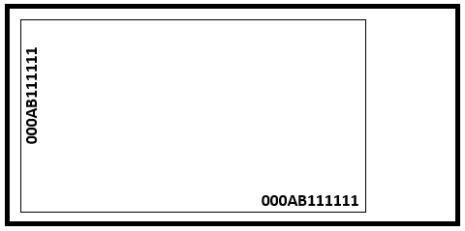**Picture 1**