Requirements for qualification samples
The testing of functionality of personalization machine

List of requirements and the testing process for qualification samples

To find the abilities and limits of a personalization devices we will provide a set of testing white polycarbonate (PC) cards with CLI feature and polyvinyl chloride (PVC) cards without CLI feature. Each participant will also be provided with a flash drive containing the personalization data. The personalization data contain a testing photo of a person and a set of two different testing motifs. Each motif is designed to test a specific ability of the production device. The picture 1 shows the testing motifs on the front side of card. The picture 2 shows testing motifs on the reverse side of card. The detail of each motif is described below.
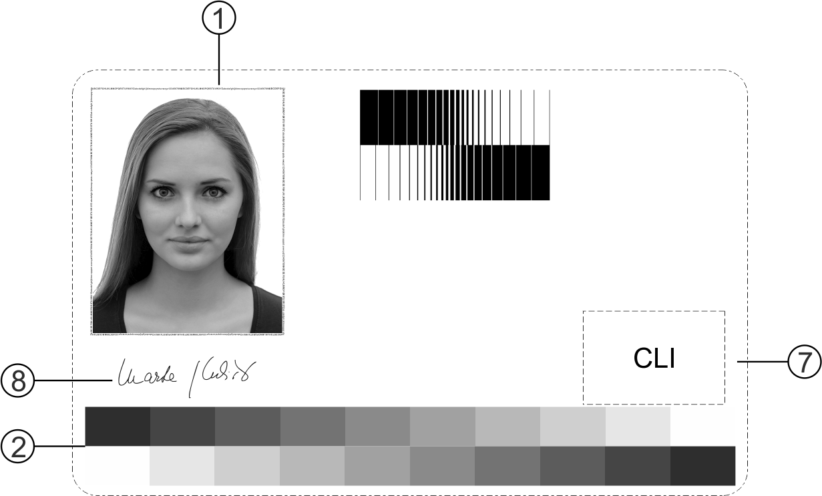
Picture 1: Testing motif – front side
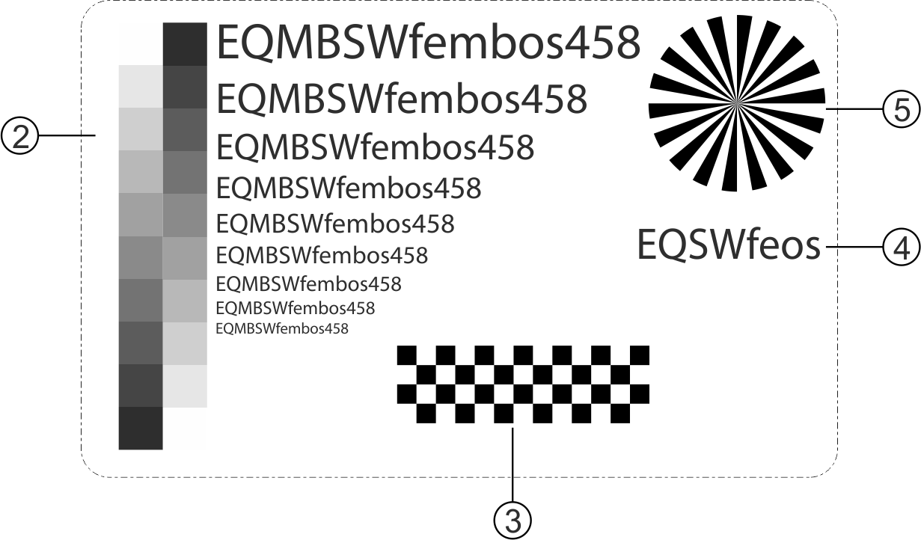
Picture 2: Testing motif - back side

- Microtext 200um
We will evaluate the readability of letters when rotated by 0°, 90°, 180°, 360° utilizing a digital microscope made by Dino-Lite. The microtext must be readable, that means lacking any deformations or filling in letters.

- Transition from white to black in vertical and horizontal direction.
We will evaluate the position of 50% grey, ideal position should be in the middle of the stripe. We will use Spectodense from Techkon as a measurement device.

- Chessboard – tactile image
This feature is used for testing of tactility of an image. Black part – tactile, white part – surface.
We will evaluate the edge of tactile image and its integrity.
- Tactile letters
We will check the filling in the letters, numbers. For example, in “E, A, P, R, M, e, a, B, b, 8, 6, 4, 3”

- Circle image
We will study the transition from wide outer part to the thin inner part. Special attention will be paid to the rendering of the central part of the image. We will compare it with basic figure from personalization data. If necessary, we will evaluate this segment wit microscope.

- Vertical and horizontal lines
We will check whether the produced line thickness is the same as the designed line thickness. We will use digital microscope for line thickness measurement.

- CLI feature
We will evaluate the whether the feature works as intended or not. We recommend the angle around 30° for setting of the laser. It depends on the individual setting of each device.

- Signature
We will evaluate whether the produced signature represent adequate rendering of the provided signature image. The delicacy of lines must be preserved.

- Text series
We will evaluate the minimal font size that shows a good enough readability.

The Contracting Authority will provide each participant with the following material for testing samples (Device):

- three (3) PC cards;
- three (3) PVC cards for testing purposes;
- flash disk containing the personalization data

Method of handing over material for testing:

- The participant shall request the Contracting Authority to forward the material for testing, in writing to the following e-mail address: rehackova.monika@stc.cz.

- Subsequently, the method of delivery of the material will be agreed:

- by personal delivery at the address of the Contracting Authority (Růžová 943/6, Nové Město, 110 00 Praha 1, Czech Republic)
- by sending it to the supplier´s requested address.

- The handover of material for testing samples can be requested a maximum of 5 days before the end of the deadline for tender submitting.

By the submitting a ternder including qualification samples, The Contractor solemnly declares that these samples have been produced on the Device offered by the Contractor.

