- General Technical Specification of the Numbering boxes for sequential numbering of banknotes
Required technical parameters
Nr. | Request of Contracting Authority: | Required amount (pcs) | The declaration of supplier that it meets all the requirements of the Contracting Authority:
1 | Numbering boxes with typical print: 000AB111111 (horizontal + vertical)  A = Letter wheel 11 division  B = Letter wheel 11 division  0 = Figure wheel 11 division, engraved 0-9 and low blank  1 = Figure wheel automatic counting  re: orientation of vertical print see enclosed Picture 1 | 120 | [YES / NO]
2 | 11 digits, forward counting, Pre-Inking device for the automatic figure  wheels; Designed for printing speed minimal 10.000 sheet per hours | - | [YES / NO]
3 | Engraving: OCR-B no. 302 for figures and OCR-B no. 304 for letters with increased figure height 3,3 mm, center distance 3,32 mm | - | [YES / NO]
4 | Letter wheels, horizontal - engraved: ABCDEFGHIJ and low blank | 120 | [YES / NO]
5 | Additional letter wheels, horizontal - engraved: KLMNOPQRST and low blank | 120 | [YES / NO]
6 | Additional letter wheels horizontal - engraved: UVWXYZZZZZ and low blank | 120 | [YES / NO]
7 | Letter wheels, vertical - engraved: ABCDEFGHIJ and low blank | 120 | [YES / NO]
8 | Additional letter wheels, vertical, Position 7 - engraved: KLMNOPQRST and low blank | 60 | [YES / NO]
9 | Additional letter wheels, vertical, Position 8 - engraved: KLMNOPQRST and low blank | 60 | [YES / NO]
10 | Additional letter wheels, vertical, Position 7 - engraved: UVWXYZZZZZ and low blank | 60 | [YES / NO]
11 | Additional letter wheels, vertical, Position 8 - engraved: UVWXYZZZZZ and low blank | 60 | [YES / NO]
12 | Split design (base + numbering wheels assembly) to maintain adjusted position of a print | - | [YES / NO]
13 | Tool less daily use (“click-in” design) | - | [YES / NO]
14 | Same base for horizontal and vertical numbering | 120 | [YES / NO]
15 | Common spare parts for horizontal and vertical numbering boxes | - | [YES / NO]
16 | Use of different fonts / pitches in one common wheels assembly | - | [YES / NO]
17 | Modification of existing numbering machine Koenig & Bauer AG Numerota II (S/N 64700903)
18 | Cams with single sided cam track, for horizontal print | 5 | [YES / NO]
19 | Cams with single sided cam track, for vertical print | 5 | [YES / NO]
20 | Holding rings | 10 | [YES / NO]
21 | Counterweights | 80 | [YES / NO]
22 | Center rings for cams | 2 | [YES / NO]
23 | Setting gauge for inking rollers | 2 | [YES / NO]

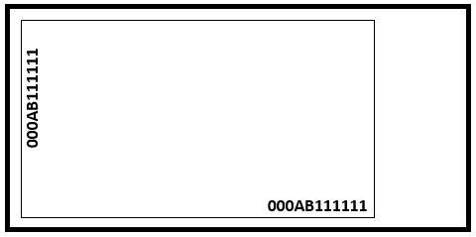
Picture 1

